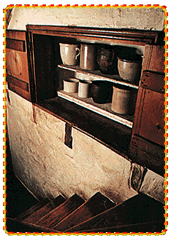
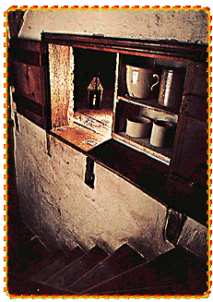
- The Underground Railroad was not underground at all, and it was not a real railroad. Because escaping slaves and the people who helped them were technically breaking the law, they had to stay out of sight. They went “underground” in terms of concealing (hiding) their actions. Sometimes they even hid in unusual places like shown below. The people who provided safe places for slaves as they made their way North were abolitionists, people who wanted to abolish, or get rid of slavery.

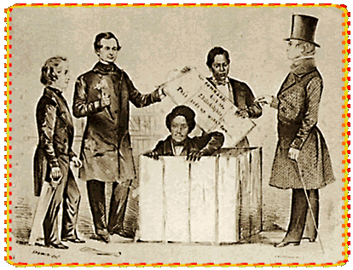
Because South Carolina was too far from the border with the North, and even farther from Canada where many slaves went, the Underground Railroad was not very effective in South Carolina.
Henry “Box” Brown, a slave, had himself shipped from Richmond to Philadelphia in a wooden Box.

