The surrender of General, Lord Cornwallis at Yorktown
(Source: Library of Congress)
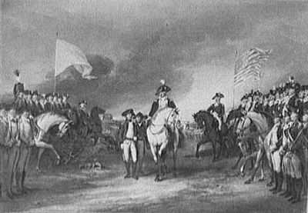
By the summer of 1781, the American troops managed to force Cornwallis and his army to Yorktown, Virginia. The French naval fleet was on its way to Chesapeake Bay to support the American soldiers surrounding Yorktown.
On September 5, 1771, the French fleet attacked the British navy in Chesapeake Bay. After defeating the British Navy, French Admiral de Grass positioned his fleet and began bombarding the forts with Cornwallis and his troops.
Cornwallis was trapped between the American army and the French navy. By mid-October, Cornwallis was running out of food and ammunition. On October 19, 1781, General Cornwallis and 8,000 British troops surrendered.
Although this was only one quarter of the British troops in America, the surrender has a devastating affect on the British government, who were now concerned they were losing the war.
They were now motivated to negotiate the end of the war, and the Treat of Paris.
