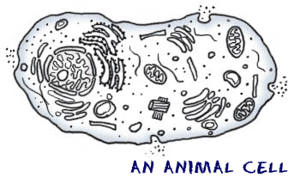
The cell is the basic unit of life. Some organisms are made up of a single cell, like bacteria, while others are made up of trillions of cells. We're made up of cells, too.
Different Types of Cells
Each cell is different and performs a different function. In the human body we have nerve cells that can be as long as from our feet to our spinal cord and help transport messages. We also have billions of tiny little brain cells and muscle cells that help us move around. There are many more cells in our body that help us to function and stay alive.
Parts of the Cell
There are a lot of parts and functions to some cells. Here are some of the man components many cells have:
- Cell Membrane - This is the outer boundary of the cell. Sort of like the skin. It allows some substance in and keeps others out.
- Mitochondria - This is where the cell gets its energy. In the human body food we have digested and oxygen react here to make energy for the cell.
- Nucleus - The nucleus is the brains of the cell. It uses chromosomes to instruct the rest of the cell what to do next.
- Cytoplasm - This is the stuff that fills up the rest of the cell. The other components of the cell float around in the cytoplasm. It's mostly water.
- Vacuoles - Vacuoles are storage units in the cell. They might store food or water any variety of nutrients a cell might need to survive.
Fun Facts About Cells
- They were discovered by scientist Robert Hooke.
- The largest known cells are ostrich eggs. They can weigh over three pounds.
- When many cells of the same kind are together in a group, it's call tissue.
- The word cell comes from the Latin word cellula, which means small room.
- Humans actually carry more bacteria cells than human cells. Yuck!

