The Phases of the Moon

The revolution of the Moon around the Earth makes the Moon appear as if it is changing shape in the sky. From Earth we see the Moon grow from a thin crescent to a full disk (or full moon) and then shrink back to a thin crescent again before vanishing for a few days.
The lit part of the Moon always points the way to the Sun.
What is the phase of the moon?  The changing shape of the bright part of the Moon that we see is called its phase. | What causes part of the Moon to be lit up?  The moon is illuminated because it reflects the light from the sun. The part of the moon facing the sun is lit up. The part facing away from the sun is in darkness.
The Moon phases are produced by the alignment of the Moon and the Sun in the sky.

What causes the different phases of the Moon?  The phases of the Moon depend on its position in relation to the Sun and Earth. As the Moon makes its way around the Earth, we see the bright parts of the Moon's surface at different angles. These are called "phases" of the Moon. | What are the different phases of the Moon called?  The phases of the moon work in a cycle starting with the new moon.  Did you know?  Countries near the equator see the crescent moon shaped like a smile?

There are eight phases of the moon
The phases are named after how much of the moon we can see, and whether the amount visible is increasing, or decreasing each day.
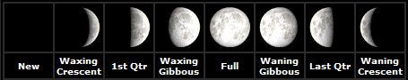
Phases of the moon as seen in the Northern Hemisphere
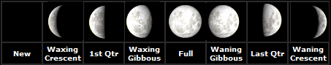
Phases of the moon as seen in the Southern Hemisphere
It takes our Moon about 29.5 days to completely cycle through all eight phases. This is known as a Lunar month

Sign our Guest Book
About Us | Search | Site Map | Feedback | User Information | Contact Us
© Mandy Barrow Terms & Conditions |
Woodlands Junior School, Hunt Road Tonbridge Kent TN10 4BB

