Clouds
What are clouds?
A cloud is a large collection of very tiny droplets of water or ice crystals. The droplets are so small and light that they can float in the air.
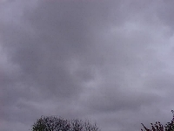
Stratus Clouds
Stratus clouds are uniform grayish clouds that often cover the entire sky. They resemble fog that doesn't reach the ground. Light mist or drizzle sometimes falls out of these clouds.
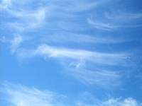
Cirrus Clouds
Cirrus clouds are the most common of the high clouds. They are composed of ice and are thin, wispy clouds blown in high winds into long streamers. Cirrus clouds are usually white and predict fair to pleasant weather. By watching the movement of cirrus clouds you can tell from which direction weather is approaching. When you see cirrus clouds, it usually means that a change in the weather will occur within 24 hours.
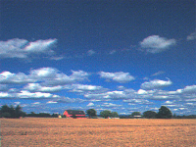
Cumulus Clouds
Cumulus clouds are white, puffy clouds that look like pieces of floating cotton. Cumulus clouds are often called "fair-weather clouds". The base of each cloud is flat and the top of each cloud has rounded towers. When the top of the cumulus clouds resemble the head of a cauliflower, it is called towering cumulus. These clouds grow upward and they can develop into giant cumulonimbus clouds, which are thunderstorm clouds.

